FOOD SAFETY SOP - ROADSHOW/POP-UP

At Sam’s Club, our commitment to our members is unparalleled and we are always working to provide safe, quality foods in our Clubs. As part of our commitment to continuous improvement, we push for the adoption of harmonized, leading-edge food safety and quality standards throughout the entire food production chain. As a result, we encourage all food suppliers to work towards obtaining full GFSI certification; however, we understand that this may not be feasible for all suppliers right now.

Suppliers applying for the Roadshow program must meet our Food Safety requirements at each facility manufacturing or producing their products. Facilities can obtain a GFSI-recognized certification, a Global Markets audit, or a Third-Party audit. Audits must be renewed annually on or before the expiration date. Please refer to the Food Safety approved audits (below) for more information.

The information you provide will be vetted through our Food Safety team for approval. Ensure plans are in place within your process to account for review time.

- GFSI-recognized certification, a Global Markets audit, or a Third-Party audit (see list of approved 3rd party audit providers below).
- Provide a copy of the health department license/permit for each location (if required)- It is the vendor’s responsibility to contact the local health jurisdiction. Some health jurisdictions require a separate permit for temporary events.
Note: If a food truck is included in the event, you will have to complete a separate food safety request form for food trucks.
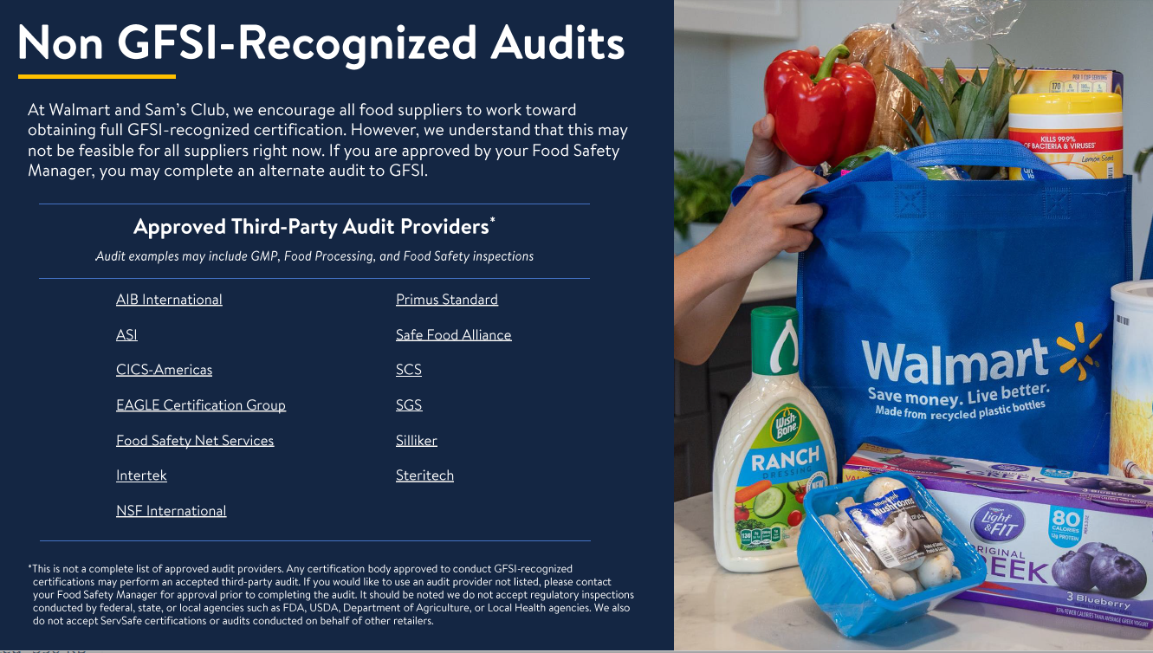
- Provide a copy of the Food Safety Manager Certification for each person activating the event (for event manager or supervisor- this individual must be present at time of event). Some jurisdictions may also require an additional food handlers card/permit for every food worker, please check with the local health jurisdiction.

Additional information may be requested, depending on the event details provided below:
If your event involves food prep for sampling purposes, please provide specific details below to include everything in the food prep process - transport, cooking temperatures, temp/time logs, handwashing, gloves/hairnets, equipment etc.
- See Food Safety Request form for details needed

*Please Note: Fresh produce, eggs, raw seafood (including sushi) & raw meat products should not be considered for Sam’s Roadshow or In-Store/Club Demo Purposes

Additional Requirements
- No food or equipment shall be left unattended during any food demo event.
- Samples shall never be given to children without parental/guardian consent.
- Any food preparation done prior to the event must be done in an inspected/regulated approved facility.
- All vendors must correct any issue immediately identified by a regulatory agency, compliance managers, our 3rd party auditing company or food safety managers and work with the store management to ensure it is corrected going forward.
- All vendors must have a calibrated metal stem thermometer present at the event when there are food items that require temperature control such as: cooking, reheating, cold holding or hot holding.
- All vendor associates must be trained on our Basic Food Safety High five which can be found in our food safety demo/vendor guide.
- All vendor associates must be knowledgeable of the NINE major allergens (recognized in the U.S) that are in or may be contained in the demo product. An ingredient statement must be documented and maintained on site at all demo stations, which accurately reflect the ingredients of each finished demo product. The NINE major allergens are Peanuts, Wheat, Soybeans, Fish, Crustacean shellfish, Tree nuts, Milk, Eggs, and Sesame.

Please utilize the following when establishing your event(s):
Elevated High Risk

- Definition: Raw proteins (including ground and whole muscle proteins).
- Example Items: Raw Ground Beef, Raw Chicken, Raw Ground Turkey, Bacon, Steak, Pork Chops, Seafood, Fresh Whole-Shell Eggs.
- Minimum Solo Requirements: Hand Washing Station, Certified Food Manager Executing. If event is in a food truck or outside the building it will need a 3-compartment sink.
Not allowed for Pop-up Shop

Low Risk
- Definition: Items that are shelf stable, pre-packaged and are served in the original packaging.

- Examples:
  - Open: Dry grocery, shelf stable beverages, snack items, bread, tea/coffee, shelf stable creamers, whole produce with peels that cannot be eaten (oranges, bananas, or avocados). Anything Ready-to-Eat but needs to be opened and handled to serve.
  - Minimum Solo Requirements: HWS not required. If items will be opened or re-packaged for customers/members, then a HWS must be within 25 ft.
  - Pre-packaged single serve: Individually wrapped chocolates, gum, candy, snacks (cannot open or remove from wrapping when distributing). Any packaged item that is given out unopened.

Medium Risk
- Definition: Items that will be required to be reheated, kept cold or hot (includes pre-cooked proteins).
- Examples: Liquid Eggs/Boiled eggs, Dairy, Produce, Pre-cooked proteins, leafy green, cut fruits, frozen items, refrigerated items.
- Minimum Solo Requirements: HWS within 25 ft., Certified Food Safety Manager Executing. If event is in a food truck or outside the building it will need a hand sink and a 3 compartment sink outside.

- (REQUIRED for all events) Certified food safety manager/food protection certified manager: an individual who has demonstrated the required knowledge, skills, and abilities necessary to protect the public from foodborne illness by successfully completing a certified food manager examination through one of the accredited certification bodies below, thereby becoming certified. This is a required.
List of approved food safety manager certifications
- 1 AAA Food Safety (AAA Food Safety, LLC)- Certified Food Protection Manager
- Learn2Serve - Learn2Serve® Food Protection Manager Certification Program
- National Registry of Food Safety Professionals- Food Protection Manager Certification Program/International Certified Food Safety Manager
- National Restaurant Association Solutions- SERV Safe® Food Protection Manager Certification Program
- Responsible Training / Safeway Certifications, LLC -Food Protection Manager Certification
- The Always Food Safe Company, LLC- Food Protection Manager Certification

- Food Handler Permit: required for anyone who works in a food business that: handles food, works with surfaces that are likely to be in contact with food such as cutlery, plates and bowls. *Might be required depending on the local health jurisdiction.
- Health department license/permit: permit to sell foods and beverages that are cooked or served to the public, and which must be regulated for public safety. Health permits are typically part of the domain of a county health department. Regulations governing requirements for types of food businesses that require health permits vary widely. Please check with the local health department, if not required please provide a letter from the Health department.
- (REQUIRED) GFSI- stands for The Global Food Safety Initiative. It is a business-driven initiative for the development of food safety management systems to ensure food facilities are processing safe food for consumers.
- Global Markets audit, or a Third-Party audit- other non- GFSI recognized audits.

